**Core Java for Testers**

**Duration: 2 Days**

**Pre-Requites:** Must know c or c++ or any other programming skills

**Course Objectives:** Once training is completed participants will be ready to learn Selenium

**Certification Link:**

* None

**Pre- Training Udemy Course Link:**

<https://www.udemy.com/course/java-programming-complete-beginner-to-advanced/>

**Post- Training Udemy Course Link:**

<https://www.udemy.com/course/java-the-complete-java-developer-course/>

**Lab Setup:**

* Windows Machine
* RAM: 8 GB
* JDK 1.8
* Eclipse for Java Development

**Course Outline:**

**Day 1:**

**OOPS**

* Encapsulation
* Inheritance, Is-A, Has-A
* Polymorphism
* Overridden Methods
* Overloaded Methods
* Reference Variable Casting
* Implementing an Interface
* Return Type Declarations
* Returning a Value
* Constructors and Instantiation
* Default Constructor
* Overloaded Constructors
* Static Variables and Methods

**Day 1 &2:**

**Generics and Collections**

* The Java Collections Framework
  + List Interface
  + Set Interface
  + Map Interface
* Using the Collections Framework
* Sorting Collections and Arrays
* Generic Types

**Java Input/output**

* Byte Streams and Character Streams
* InputStream and OutputStream
* Reader and Writer classes
* Read from and write to file/console
* Serialization

JAVA :

1. Packages
2. Java Execution – Internal

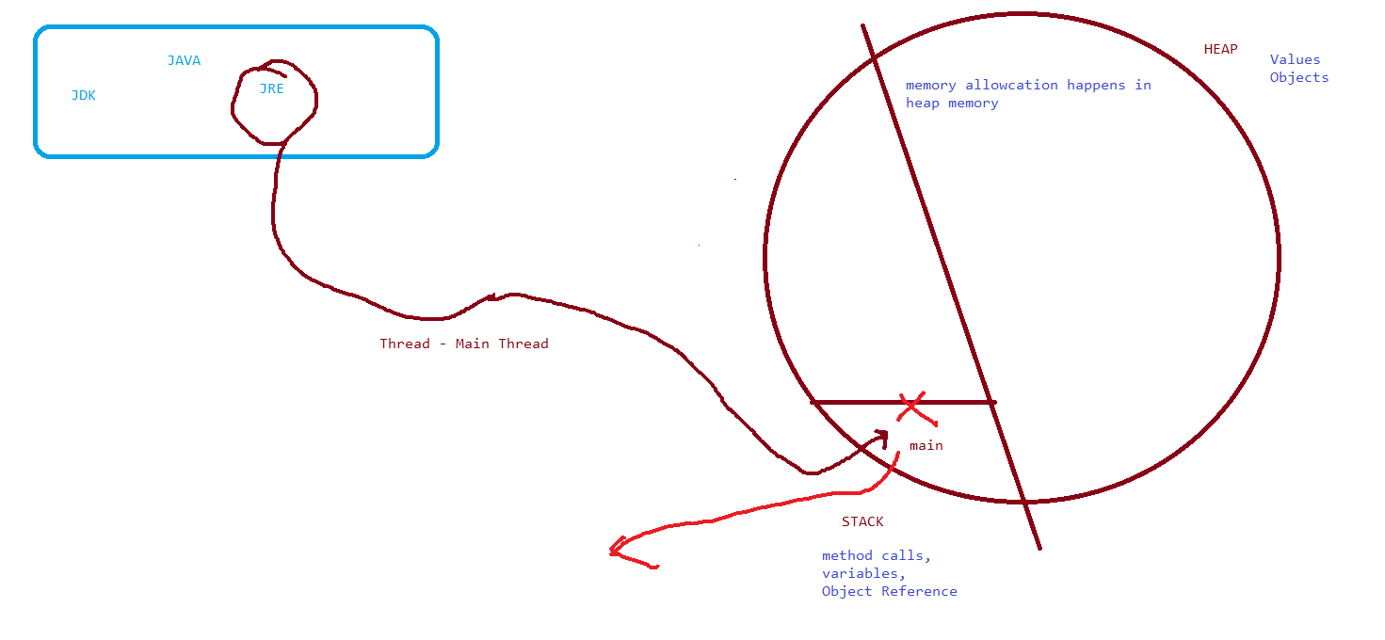

1. Data types

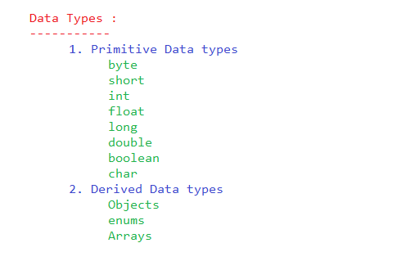

1. Variables

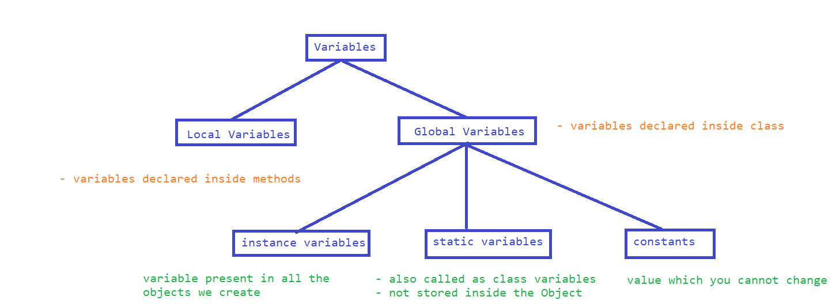

1. Scope

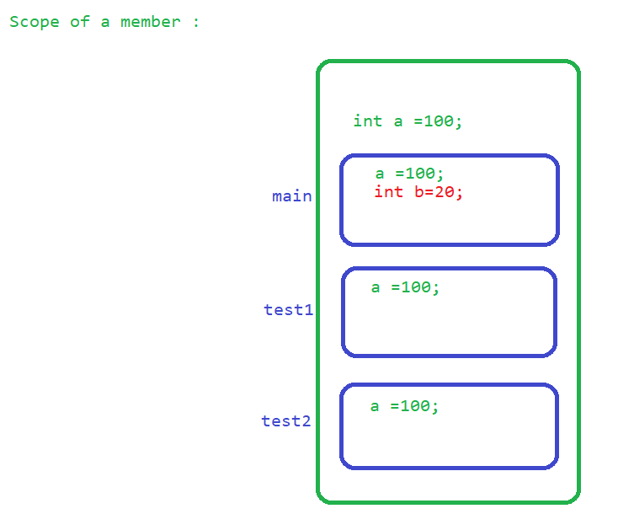

1. Execution

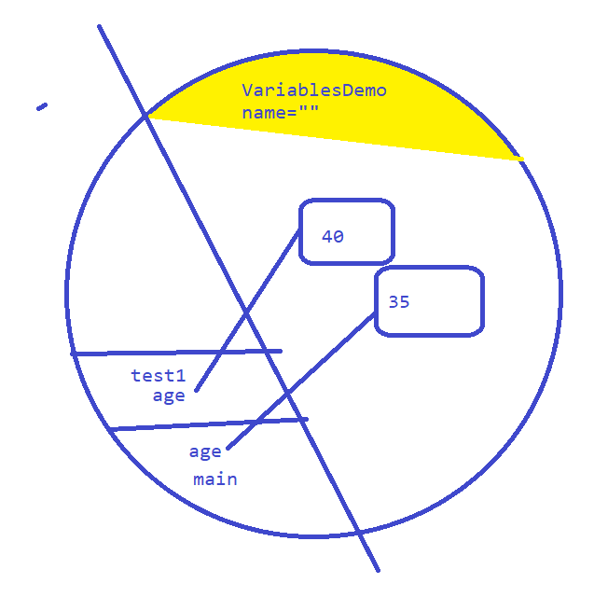

1. Methods

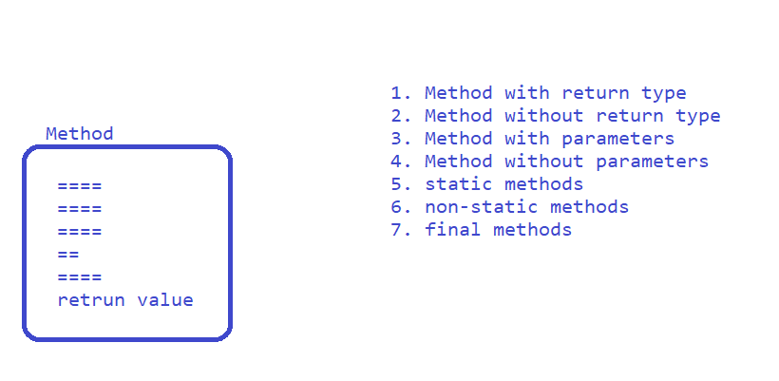

1. Constructors

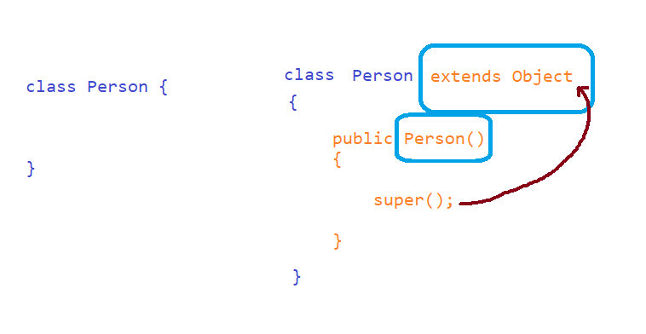

1. Execution –Internal

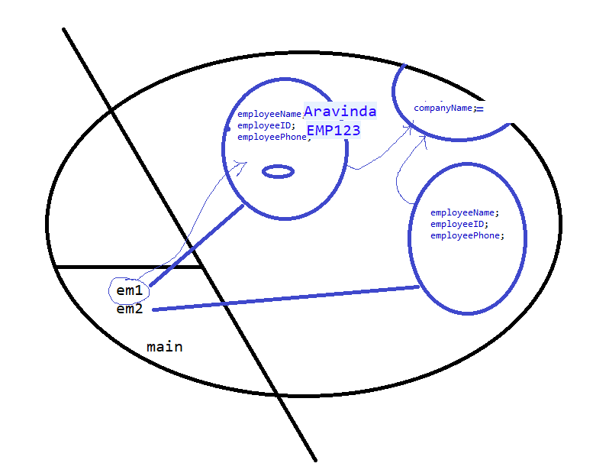

1. Polymorphism
   1. Overloading / static polymorphism / Compile time polymorphism
   2. Overriding / dynamic polymorphism / Run time polymorphism
2. Inheritance

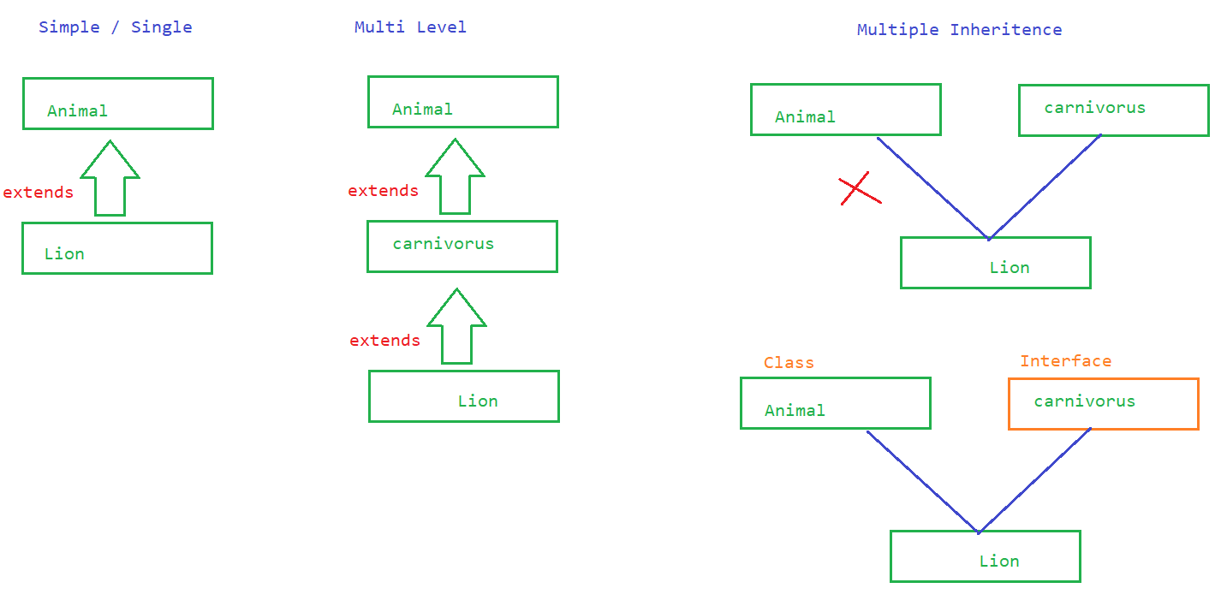

1. Abstract class
   1. class with unimplemented methods
   2. OR when you want to restrict creating object to the class declare it as abstract
2. Interface
3. Access specifiers and Access modifiers

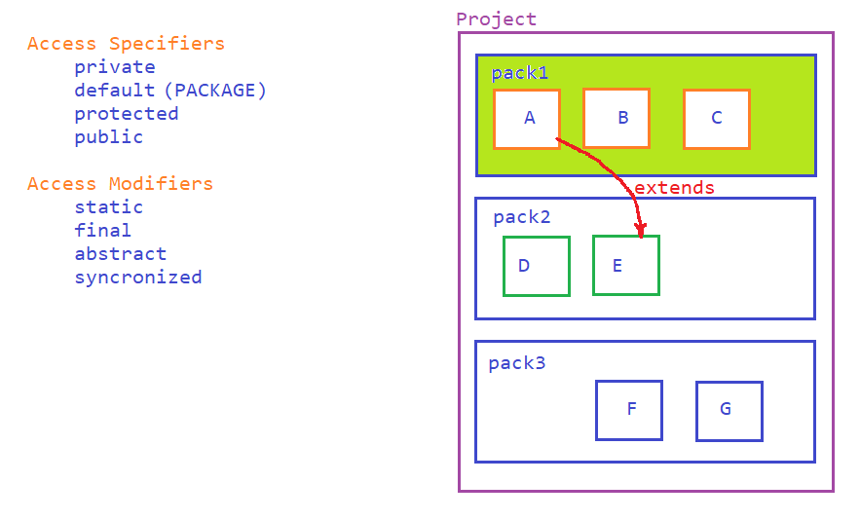

1. Write a JAVA Program to generate tables for a given number
   1. 5 * 1 = 5 ...50